Michael Bell

BeltraC

User Manual

Contents

Introduction 2

Setup 3

Directing the train 4

Changing Settings 5

Opening the box 6

Sensors 7

Point Motors 8

Troubleshooting 10

Introduction

Welcome to Beltrac!

This manual will help you understand how to use your new train track system.

Beltrac is pre implemented and is simple and easy to use, however there are a few things you should know before getting started.

Follow these simple instructions and it will bring you years of pleasure.

Setup

Before running Beltrac you must place the train on the track. Before doing so, check that the magnet provided with the system is attached to the middle of the train with the dot facing downwards toward the track. Standing at the control panel the train can then be placed on the track with the front pointing to your right.

You can now plug in the system - Beltrac has 2 plugs, one large and heavy with Hornby written on it and one small and light. The larger plug should be plugged in first and then the smaller.

It will take a few seconds for the system to start up, during which time the top half of the LCD will be filled with small squares.

Welcome to Beltrac!

When the display reads this then you are ready to go!

Directing the train

Welcome to Beltrac!

When this is displayed, press the → button

Destinations :

Press it again to enter the list of destinations then use↑and ↓to select a destination then press enter, the train will then navigate itself to its destination and no further action is required, when it returns to the main screen you can begin again.

Changing Settings

Welcome to Beltrac!

When this is displayed, press the → button

Destinations :

Press ↓

Settings :

Press →

Backlight : 50

Keep pressing enter to change the backlight when you are satisfied press ←

changing Parts

# Opening the box

Should you encounter problems with Beltrac, you may need to open the cover of the box with the LCD. Beltrac is covered by a black box which is opened by removing the 6 screws on the underside of the box, under the table, and then lifting the cover off, being careful not to dislodge any wires.

This is what it looks like on the inside:

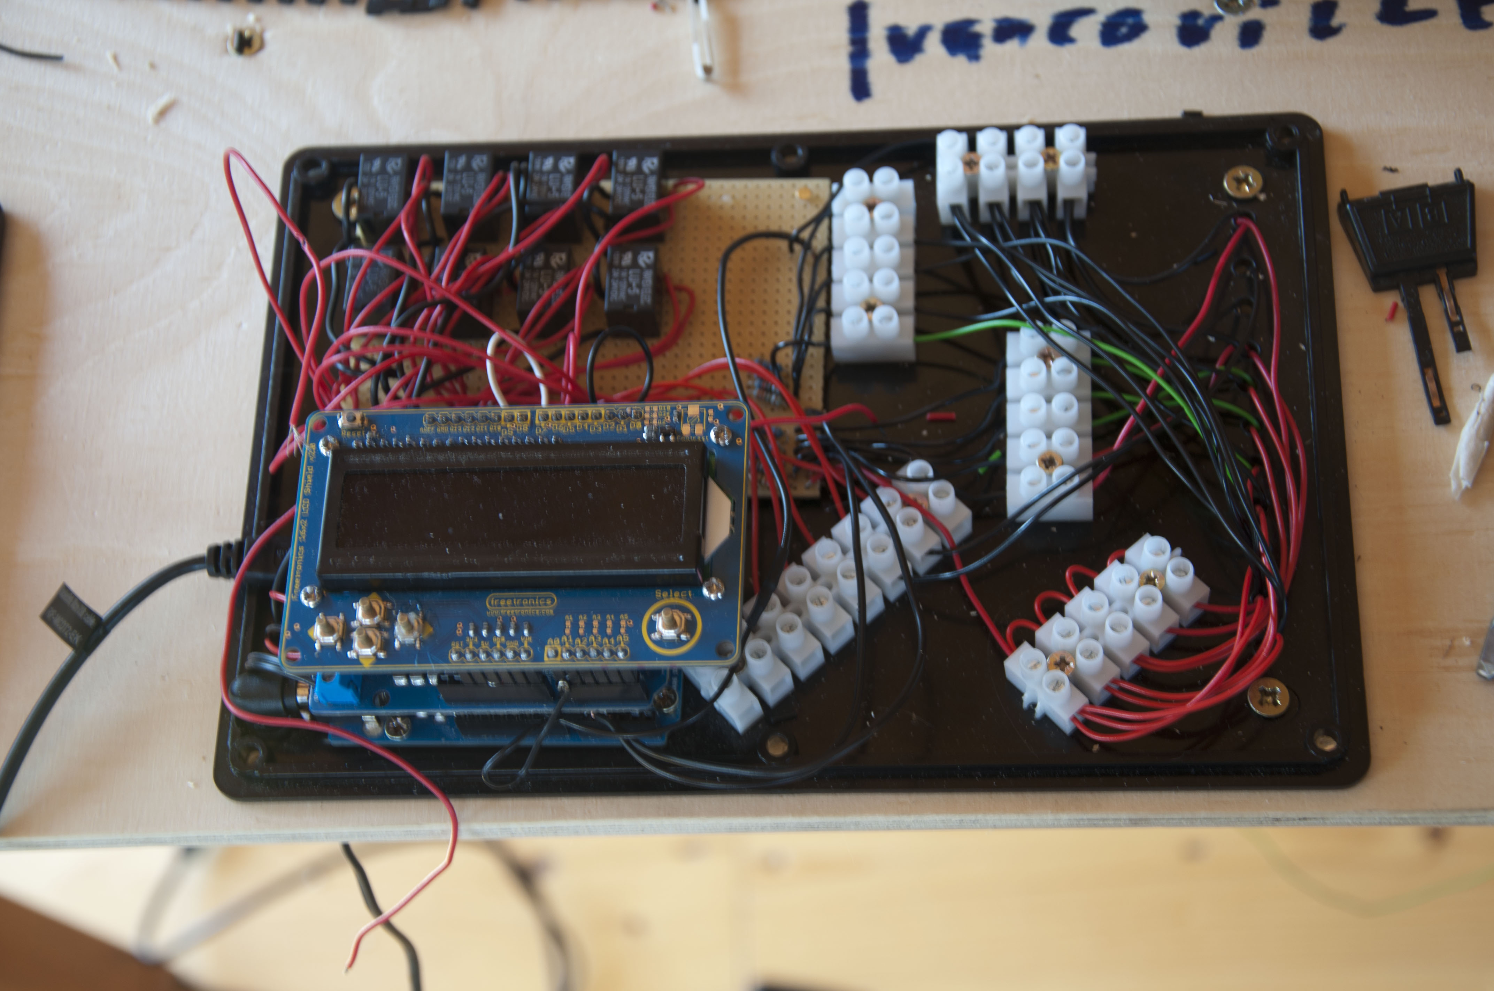

# Sensors

Beltrac detects the position of the train using devices called Hall Effect sensors (shown here) these are available from places such as Farnell and Radio Spares and are easy to attach to the system. Simply solder a wire to each of the terminals on the sensor, then attach each wire onto the Beltrac board as shown here (no. 3 can be attached to one of two places).

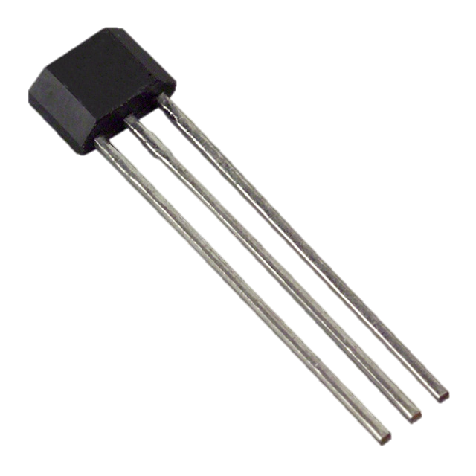

1

2

3



1

2

3

3

# Point Motors

Point motors are similar to sensors but are slightly tougher to install, first, purchase one either directly from Hornby or from a model shop.

Then, solder longer wires to the 3 that already run off the sensor, then, solder a diode to both, the green and red wires but not the black wires, the diodes should have the white band facing the motor and away from the board and should be protected with heat shrink.

The replacement point motor should sit snuggly inside its assembly with the wires hanging down underneath.

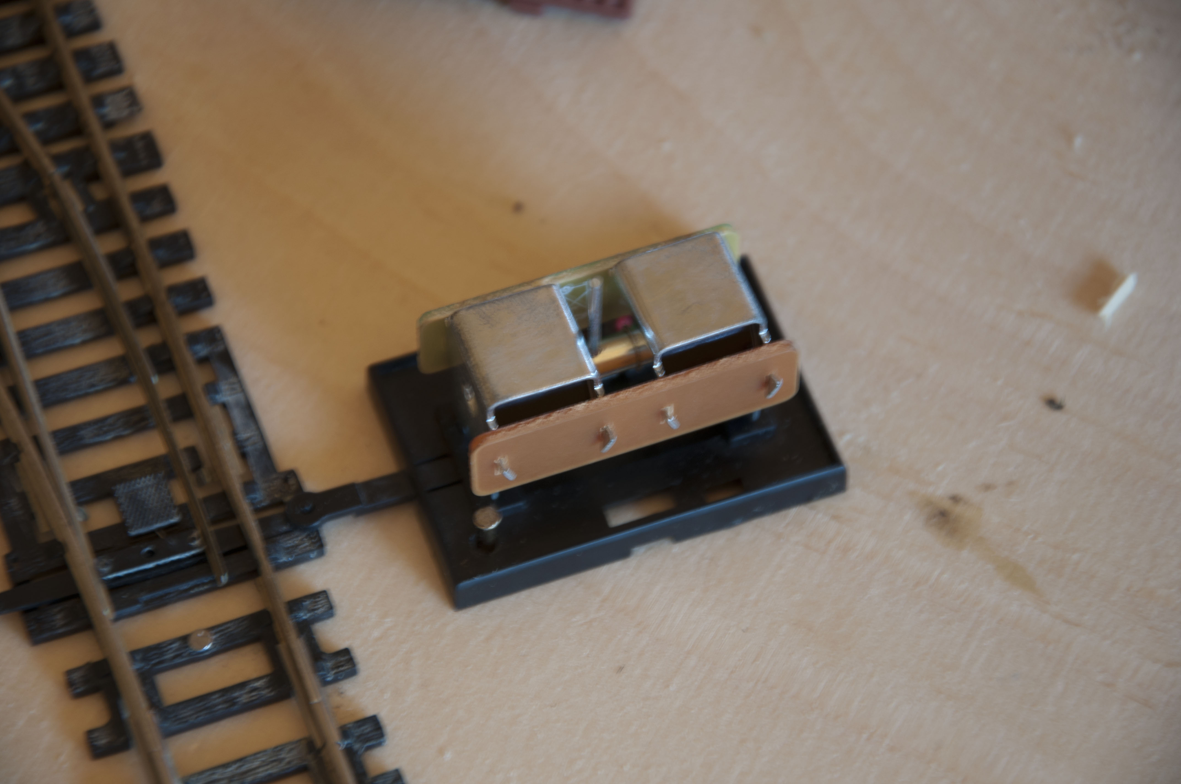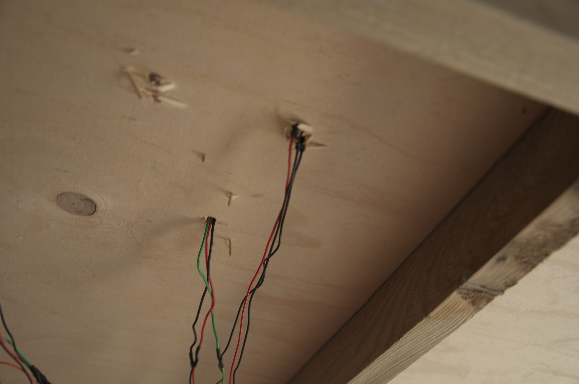

Then, attach the black wire to the board here,



Here

And the diodes (with their appropriate wires) underneath the enclosure here,

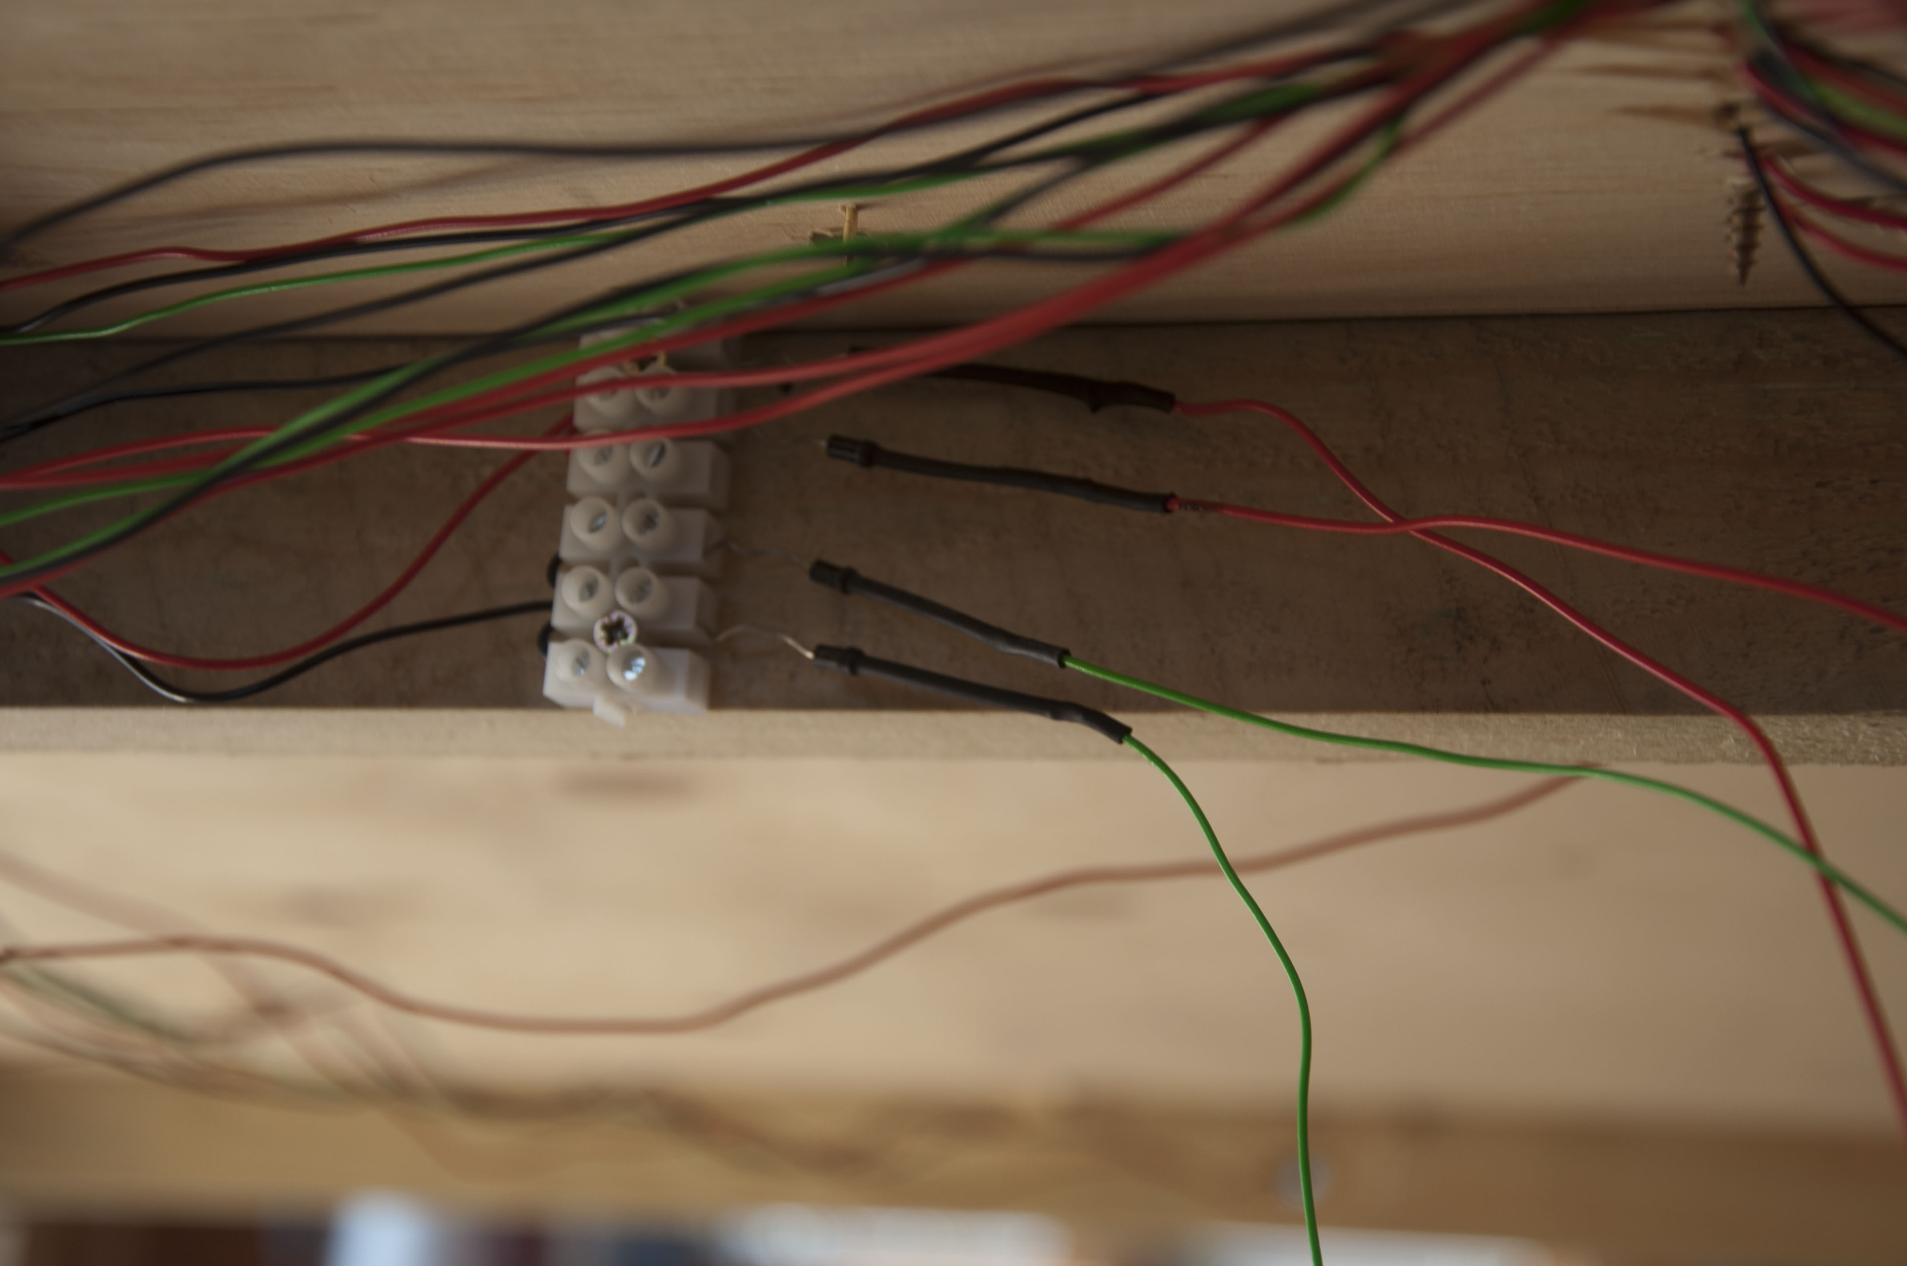

Green

Red

Troubleshooting

Should you have any problems with Beltrac this table should help you sort them out.

|  |  |  |
| --- | --- | --- |
| Problem | Cause | Fix |
| The train gets stuck on a buffer. | The train has not been detected by a sensor. | Switch off the power, return the train to the start then switch the power back on again. |
| The train slowly grinds to a halt unexpectedly. | The transformer has overheated. | Unplug the system and leave it for 10 minutes to cool. |
| The train jolts to a stop and sits at a jaunty angle. | The train has derailed. | Unplug the system, return the train to the start then begin again. |
| A point refuses to change. | There is either a fault with the wiring or failing that the motor needs replacing. | Check the wiring of the point motor and if it still does not work, replace as described above. |
| The board cannot detect the train at one specific location. | The hall effect switch needs replacing. | Refer to instructions above. |
| The train is not detectable | The train has lost its magnet. | Affix a small magnet to the bottom of the train, if it still does not work, turn the magnet the other way around. |